|  |
| --- |
| **Nepal Chamber of Commerce Highlights Key Initiatives and Strategic Engagements** |

**Chamber Emphasizes Investment-Friendly Tax System-***November 3, 2024*

The Nepal Chamber of Commerce (NCC) organized a high-level interaction on revenue policy and tax reform at its headquarters in Jamal, Kathmandu. Engaging stakeholders from the Department of Internal Revenue and the private sector, the discussion focused on identifying critical challenges and reform opportunities. NCC President Mr. Kamlesh Kumar Agrawal emphasized the need to align tax policies with investment incentives, stating, “A simplified tax administration and policy framework will foster an investment-friendly environment, enabling businesses to grow and contribute more in taxes.” He also underscored the importance of creating capital, generating employment, and boosting production through streamlined tax systems.

**Chamber Calls on Ambassador Sharma to Strengthen Nepal-India Trade Ties-***November 4, 2024*

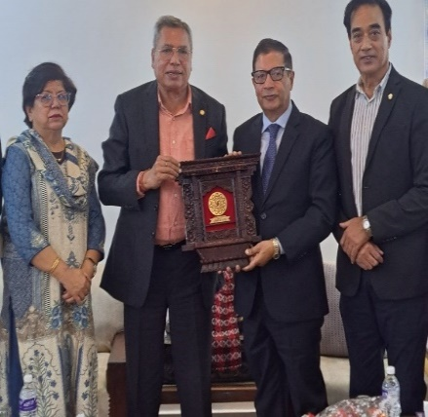Chamber leadership, led by President Agrawal, held a meeting with newly appointed Ambassador to India, Dr. Shankar Prasad Sharma. The Chamber urged enhanced facilitation of bilateral trade and investment with India, highlighting persistent issues in Nepal’s export process despite open trade policies.

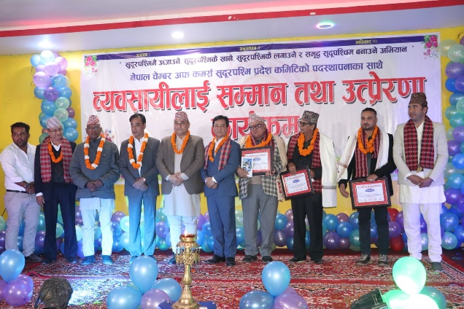**Outgoing President Malla Advocates for Sudurpaschim Province Development-D***ecember12,2024*  
At an event in Kailali, former NCC President Mr. Rajendra Malla emphasized that national prosperity hinges on the development of Sudurpaschim Province. He called for strategic investments in agriculture, tourism, and hydropower to unlock the region's potential.

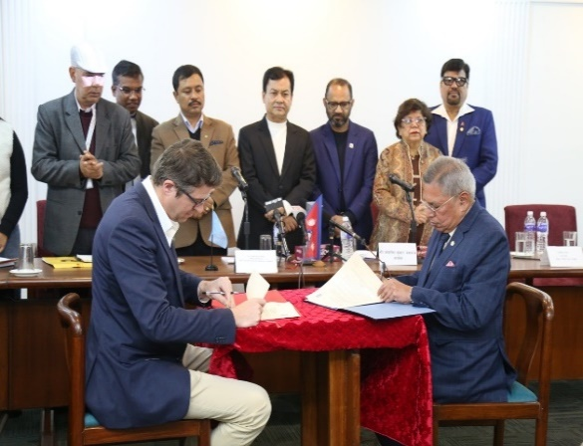**NCC and UNDP Sign Agreement for Sustainable Development-***December 16, 2024*  
Memorandum of understanding was signed between NCC and the United Nations Development Programme (UNDP) to foster collaboration in sustainable economic growth, climate resilience, disaster risk reduction, and private sector capacity-building.

**Chamber Urges Ambassadors to Prioritize Economic Diplomacy-***December 18, 2024*  
In a formal reception, the Chamber encouraged newly appointed ambassadors to place economic diplomacy at the forefront of their foreign missions, emphasizing investment promotion and export facilitation as key national priorities.

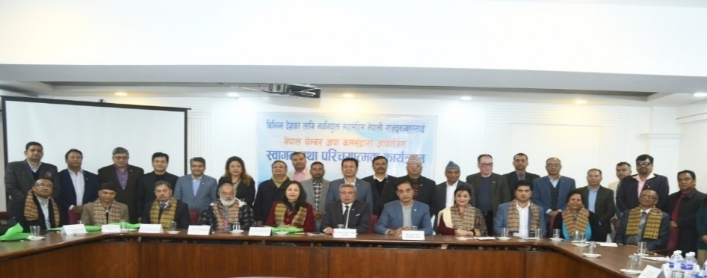

**Chamber Welcomes Economic Legal Reforms-***January 15, 2025*  
 The Chamber welcomed the government’s ordinance aimed at improving the business environment and investment climate, calling it a vital step toward long-term economic stability and public service efficiency.

**NCC and ILO Collaborate on Enhancing Social Security Fund-***January 16, 2025*

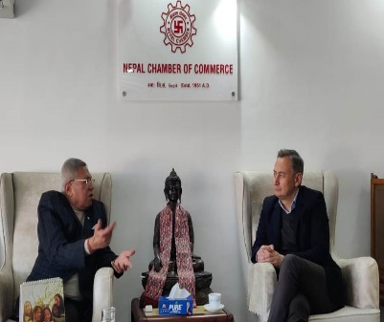Discussions were held between NCC and ILO Nepal on making the Social Security Fund more effective. Topics included workers’ rights, minimum wages, and productivity-based wage frameworks.

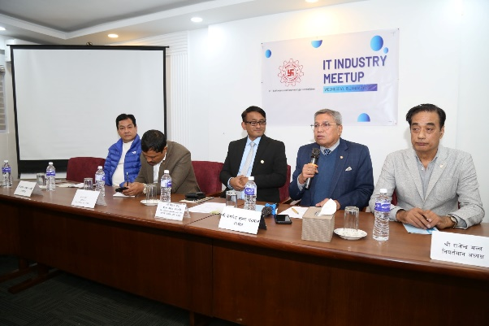**Chamber to Drive IT Investment Promotion-***January 18, 2025*

NCC announced its commitment to facilitate investments in Nepal’s burgeoning IT sector. Strategic plans are underway to boost entrepreneurship and enhance international market access through the Chamber’s dedicated IT committee.

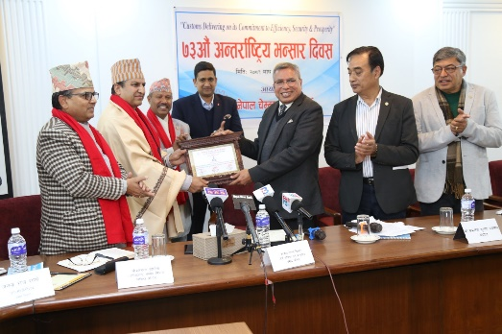**Chamber Recognizes Excellence in Customs Service-***January 23, 2025*

On the occasion of International Customs Day, NCC honored Mr. Gopal Prasad Bhattarai from the Department of Customs for his outstanding service.

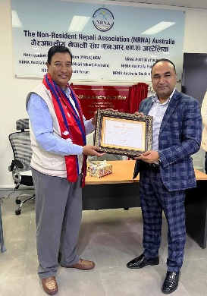**NCC Appoints Trade Representative to Australia-***February 1, 2025*

The Chamber appointed Mr. Sanjiv Sharma as its Honorary Representative to Australia to bolster trade ties and investment promotion in the region.

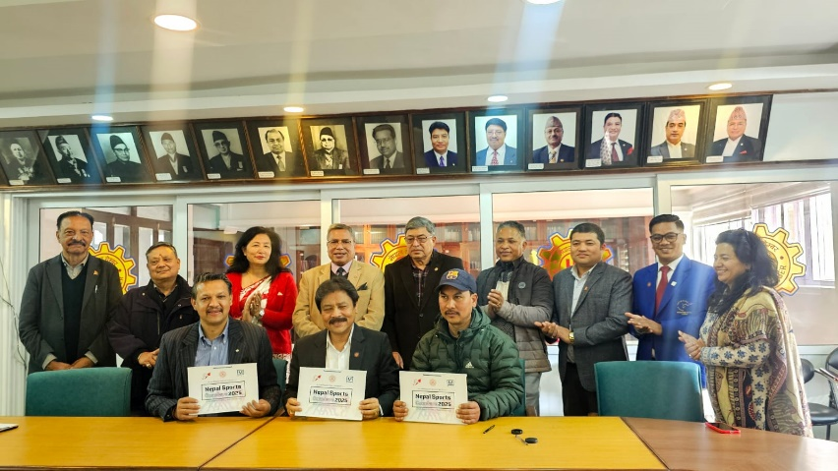**Chamber Forges Partnerships for Sports Promotion-***February 5, 2025*

In support of the growing sports industry, NCC signed agreements with key organizations to host sports exhibitions and events, promoting fitness and sports entrepreneurship.

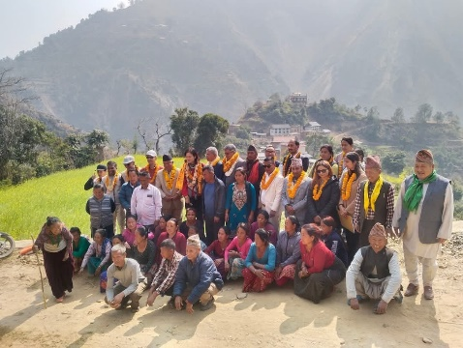**Joint Monitoring of Disaster Support in Kavrepalanchok-***February 16, 2025*

A joint NCC-UNDP mission reviewed reconstruction and livelihood initiatives in areas of Kavrepalanchok affected by floods and landslides in 2024. The team was led by NCC President Agrawal and UNDP Resident Representative Ms. Kyoko Yokosuka.

**NCC and Thailand Tourism Council Ink MoU-***Chaitra 20, 2081 (April 2, 2025)*

NCC and the Tourism Council of Thailand signed a Memorandum of Understanding to enhance cooperation in trade, tourism, and civil aviation. The agreement was signed in the presence of the Prime Ministers of both nations during a formal ceremony in Bangkok.

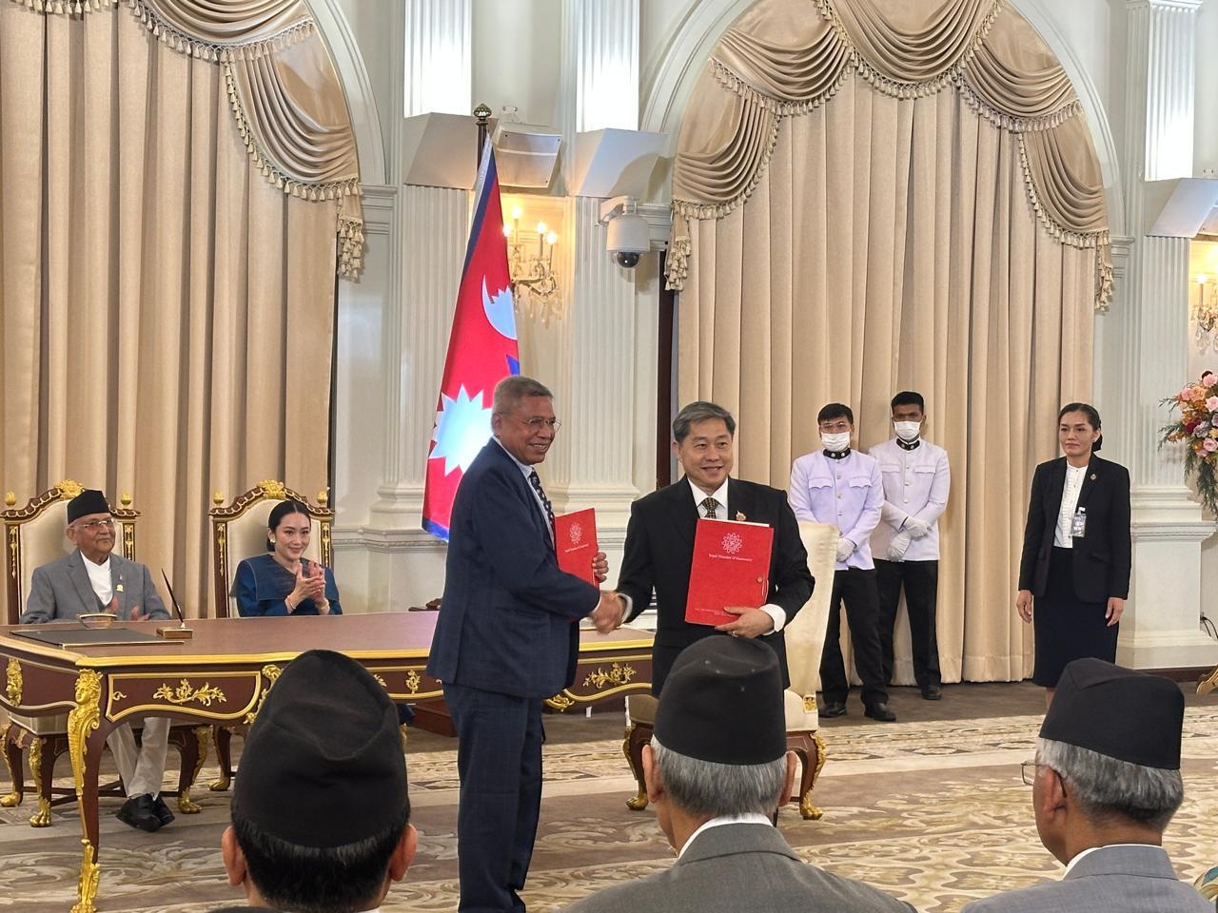

**Morang Chamber Marks Tax Day with Dialogue-***November 21, 2024*

Inland Revenue Office, Biratnagar hosted a program marking National Tax Day, where officials from the Morang Chamber of Commerce shared insights under the theme “Essence of Tax System – Foundation of Investment.”

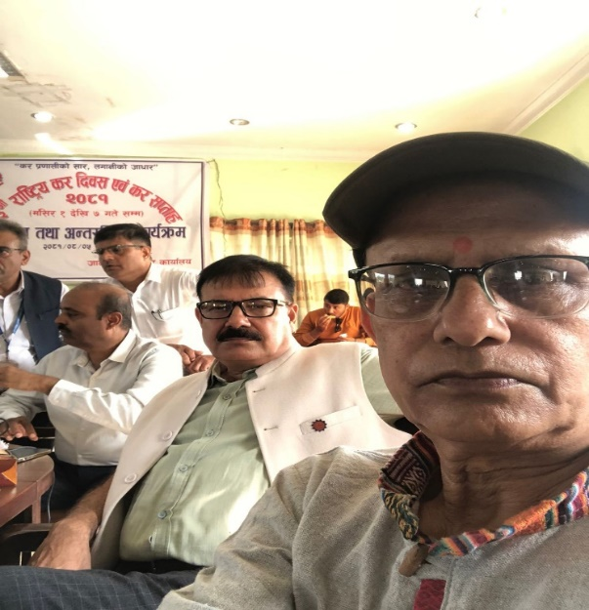

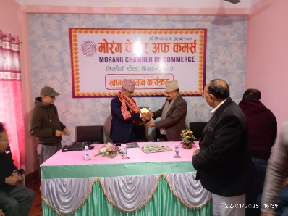**Morang Chamber President Advocates for Better Customs Environment-***January 26, 2025*

During an award ceremony by Biratnagar Customs Office, Morang Chamber President Mr. Yadav Pokharel urged for improved facilities and processes at customs points to facilitate trade.

**Udaypur Business Community Participates in Tax Day Rally-***November 17, 2024*

Members and officials of the Udaypur Trade Association took part in a public rally to raise awareness on tax compliance during National Tax Day celebrations.

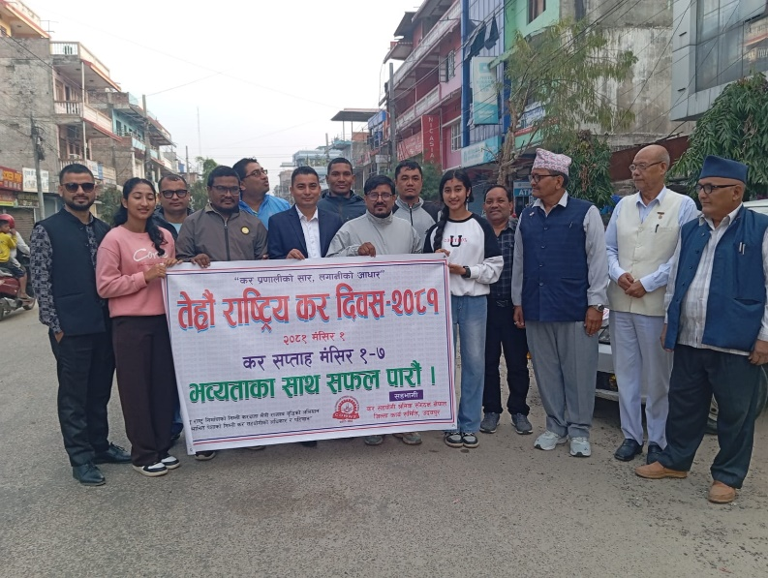

**Pink City Festival Concludes in Waling-***March 16, 2025*

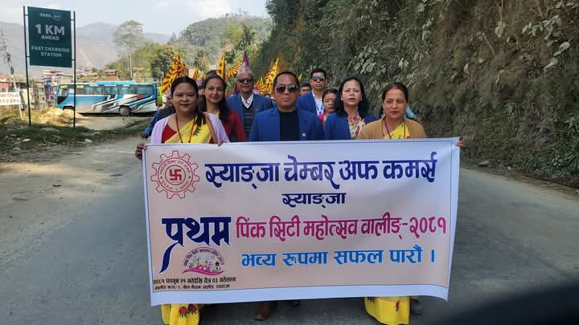The first Pink City Festival, organized by the Waling Chamber of Commerce, concluded successfully. The event, themed “Economically and Socially Prosperous Society, Prosperous Waling,” featured cultural processions and exhibitions, with participation from the Syangja Chamber and other stakeholders.

**Chamber Submits Recommendations to High-Level Economic Reform Commission**

NCC has submitted key policy recommendations to the government-appointed High-Level Economic Reform Advisory Commission. Emphasizing the need for a decade of stable policies, the Chamber advocated for an investment-conducive climate, increased productivity, job creation, and effective trade management, noting the private sector’s vital contribution to the national economy.

**Nepal Chamber Expo 2025 Inaugurated with Grandeur**

The 8th edition of the Nepal Chamber Expo2025 was officially inaugurated the Prime Minister by KP Sharma Oli, and the Minister for Communication and Information Technology, Mr. Prithvi Subba Gurung was also presence in the inauguration ceremony. With decades of legacy, the Expo2025 has grown into a premier platform for showcasing international trade, innovation, and entrepreneurship.

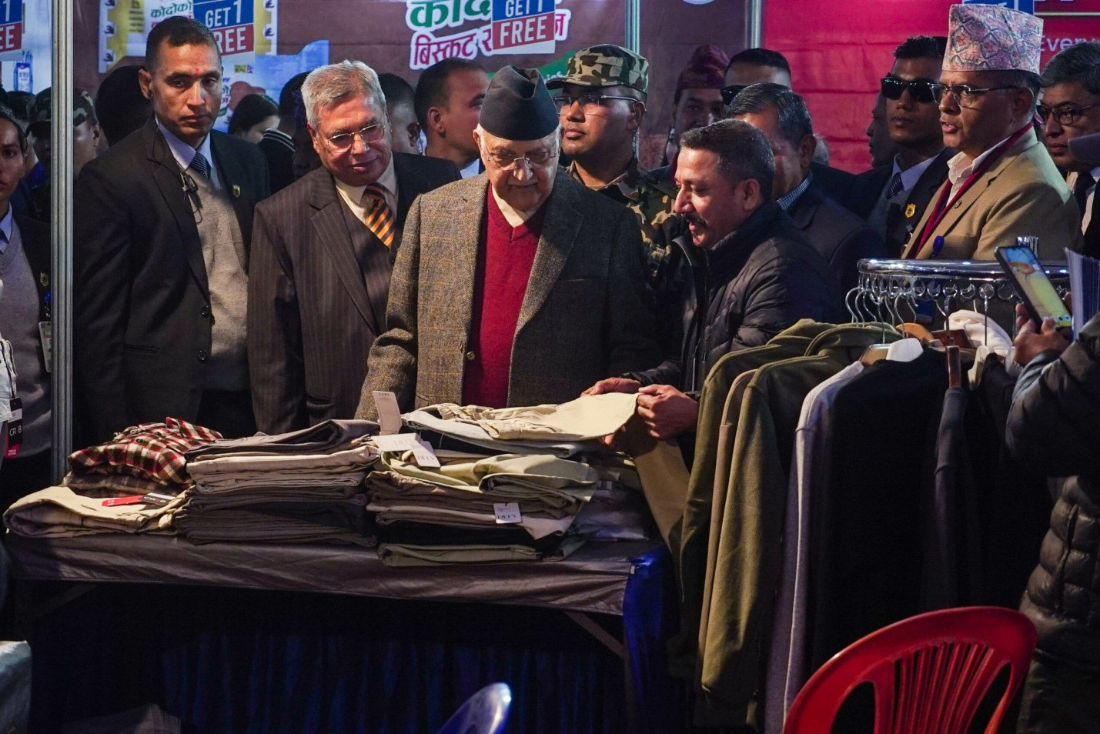

**74th Annual General Meeting** of Nepal Chamber of Commerce was conducted where prime Minister has inaugurated the AGM. Federal government ministers, high level officials of Government, diplomats, private sector representatives, NCC members, entrepreneurs, Journalist and experts were presented in the opening ceremony of the AGM. The details of President speech delivered during Inauguration of 74 AGM of Nepal chamber of commerce Nepal is given below.

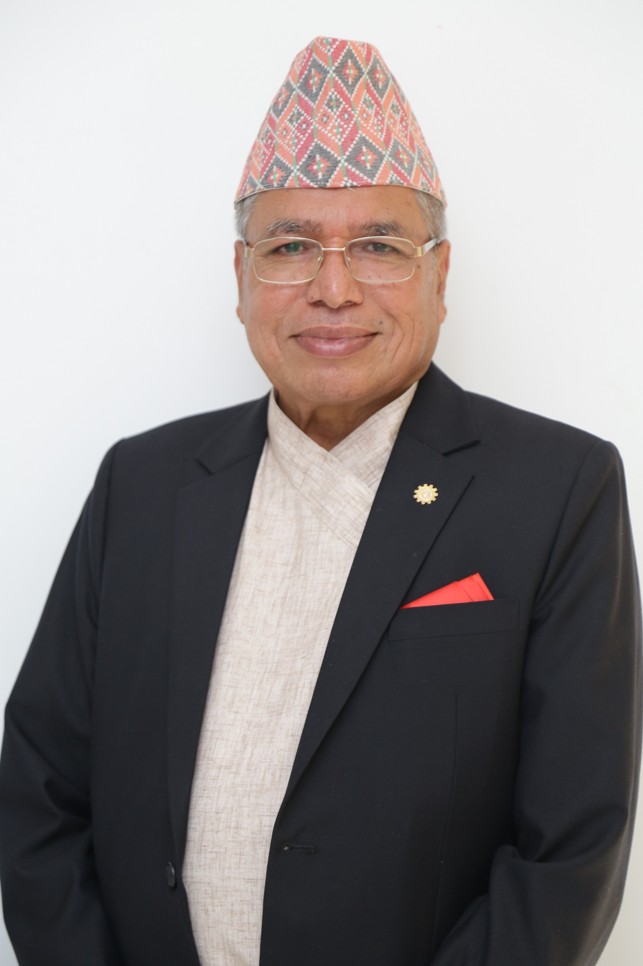

|  |
| --- |
| Mr. Kamlesh Kumar Agrawal, President of Nepal Chamber of Commerce presented welcome speech on the occasion of 74th Annual General Meeting of Nepal Chamber of Commerce.   * Hon'ble Prime Minister KP Sharma Oli the Chief Guest. * Hon'ble Deputy Prime Minister and Finance Minister Bishnu Prasad Poudel -the Special Guest. * Special Guest Hon'ble Minister for Industry, Commerce and Supplies Shri Damodar Bhandari * Secretaries and high officials of the Government of Nepal * Mr. Rajendra Malla, Immediate Past President of Nepal Chamber of Commerce, Chairman of Advisory Council Mr. Rajesh Kaji Shrestha Former presidents, vice-presidents, members of the working committee * Excellencies Ambassadors and Representative from The Diplomatic Missions * President of FNCCI, President of CNI * Presidents and office-bearers of state, district, town and rural municipality chambers * Presidents and office-bearers of various organizations * Entrepreneurs, business friends, * Journalist friends, * Ladies and gentleman   1. First of all, I extend warm welcome and greetings to the Honorable Prime Minister, Hon'ble Ministers and all the honorable guests who attended this august meeting. The chamber campaign, which has passed the 74th spring, is also a very proud moment for the entire private sector. Nepal Chamber of Commerce, the first organization to represent the active private sector for almost seven and a half decades, has been conducting various activities for the overall economic prosperity of the country and enhancing the business capacity of the private sector. The first budget of the budget system started in 2008 BS immediately after the establishment of Nepal Chamber of Commerce, was Rs 52.529 million, which has now reached Rs 18.60 billion in the current fiscal year. The Nepal chamber was /is a witness and contributor in crafting this budget preparation and implementation journey.  2. In this way, the role played by the Chamber for the development of the economy and promotion of the private sector in the country has become a matter of self-respect and belonging for all of us entrepreneurs. Today, the Chamber has been established as an indispensable representative institution for the government and the private sector. I bow to all our senior entrepreneurs who have contributed to this campaign with heartfelt respect.  3. Nepal Chamber of Commerce has been running various programs under its social responsibility. Following the loss of lives and property due to floods in Kavre district in the October 2024, the Chamber, in collaboration with the United Nations Development Program (UNDP had launched program for early recovery of Community Infrastructure under the Cash for Work Scheme. This has supported the badly affected communities from Namobuddha, Bhakundebeshi rural municipality. The Roshi river flood and land slide has damaged the farmers field, irrigation system rural agriculture roads.  4. I would like to kindly inform you that the Chamber has actively participated in the Labor and Employment Fair organized by the government in all the seven provinces where Chamber helped linking job seekers with the employers.  **5**. Nepal Chamber of Commerce working with the government, stakeholders, diplomatic missions and development partners in collaboration. The Chamber of Commerce has also been sharing its views in private sector friendly manner in the government's acts, rules and policy guidelines. The government has also been capitalizing the constructive suggestions of the chamber. The Chamber has been expressing its clear views on the issues that are likely to have an adverse impact on the economy. Therefore, we believe that the strategy shared on the basis of practical and realistic analysis of the socio-economic situation of the country, the Chamber has provided positive support to the government in formulating and implementing policies rules and action plans in the entire economic sector including industry, commerce.  6. The 8th Chamber Expo of international level organized by the Chamber has been successfully concluded in January 2025. I recall, Honorable Prime Minister, guidelines given during inauguration speech of the Expo. It has given a lot of encouragement to the expo organizer, participants and visitors that was reflected the enthusiasm and participation shown by all the stakeholders in the fair. We feel that the expo has been fruitful for the promotion and marketing of local and domestic products. Nepal Chamber of Commerce is promoting the production, marketing and use of indigenous goods as a campaign. The International Chamber Expo has significantly contributed to the promotion of Nepal's economic relations with the business companies and organizations of friendly countries through B2B. It is well known that this time the 8th Nepal Chamber of Commerce and AI Project is a special attraction of international standard.  7. At this VVIP function in the presence of the Hon'ble Prime Minister, I would like to summarize the Chamber's views on the existing challenges of the economy and its way out.  **Hon'ble Prime Minister**  8. At present, the external indicators of the Nepalese economy are depicting the good improvement so far and there are indication of improvement on the internal side as well. According to the latest data of the National Statistics Office, the economic growth is estimated to be 5.1 percent in the second quarter. The growth in the transport sector, the increase in electricity generation and distribution, and the increase in the total value addition of financial intermediation seem to have played a major role in making the economy positive. Recent increase in imports and exports, improvement in tourist arrivals, as well as statistics show signs of expansion of the economy. Earlier, Nepal’s economic growth rate was 7.7 percent from the fiscal year 2073/74 to 2075/76. However, due to the non-liberal monetary policies, the economic growth rate in the financial years 2079/80 and 2080/81 was only 1.95 percent and 3.86 percent respectively. According to the first quarter of the current fiscal year, the economic growth rate will be less than the target of 3.4 percent. Although more than Rs 700 billion is available in banks and financial institutions at low interest rates, the private sector has shown reluctances to new investments. The foreign exchange reserves have reached an all-time high of Rs 23.69 billion in the seven months of the current fiscal year. Remittances amounting to Rs 9.61 billion have come in seven months.  9. In the eight months of the current fiscal year, imports amounted to Rs 11.45 trillion, while only Rs 1.58 trillion was exported. Nepal Chamber of Commerce has been continuously taking initiatives to promote exports and manage imports. Exports have increased by 58 percent in nine months of this year as compared to eight months last year. Nepal's exports have increased due to the high customs duty imposed by India on goods exported from Nepal from other countries. This should not be seen as a long-term and sustainable export growth. For the identification and promotion of high Value-Added exportable items, it needs easy facilitation of customs including high-level quarantine labs, effective implementation of the of the export subsidy. I request you to make the incentives provided by the government on exports available to the exporters immediately. Inflation averages around 5 per cent. In the eight months of the current fiscal year, the development expenditure has been limited to 25 percent. Capital expenditure has not improved as expected  10. The private sector, which accounts for more than 81 per cent of the country's economy, has been experiencing severe economic slowdown. The industries, construction sector, real estate, wholesale and retail trade, which are important sectors of the economy, are yet to pick-up pace. The main reason behind the decrease in enthusiasm of entrepreneurs, i.e., the morale of the entrepreneurs, is the burden of old problems of the past. It is a matter of concern that more than 100,000 entrepreneurs have been blacklisted in the last two and a half years. The situation is yet to improve. The private sector has not been able to draw loans from banks and financial institutions to do business by bearing additional risks as the risk bearing capacity of the private sector is deteriorating. It is urgent to increase the confidence of the private sector to get rid of the existing economic slowdown. For this, it needs a private sector friendly economic policy, liberal monetary policy, easy investment-friendly environment in the operation of industry and trade and cooperative bureaucracy. The main problem for capital formation in the private sector is also the impractical provisions of the Working Capital Loan Guidelines -2078. It has to be postponed for some time or cancellation of guideline provision. The loans installment can be rescheduled for some time by mutual analysis with banks and financial institutions as per the need, considering the nature of the business, it can create great confidence among the affected entrepreneurs and prevent many entrepreneurs from collapsing.  11. According to the Chamber of Commerce, the impact of the COVID-19 pandemic in the past, the Global Chain impact of the wars in the Middle East through Russia and Ukraine, and more so, the narrow monetary policy adopted by the central bank at that time. Those were the main reasons of getting discourage of entrepreneurs for business promotion.  12. The private sector is encouraged as the five ordinances issued to improve the economic and business environment, investment promotion and good governance at the initiative of the present government have been passed by both houses of the federal parliament. It has enthused all investors that Nepal's economy is directed towards making it liberal market-oriented and competitive. Accordingly, we are expecting regulations and procedures as visioned in the five ordinances.  13. It is a good thing for the private sector that Nepal has received our rating BB- in the second place after India in South Asia while Nepal has got the country's sovereign credit rating from an internationally recognized institution. It is favorable for attracting foreign investment. I request to utilize this opportunity and private sector is happy to support government in this venture. However, Nepal’s asset consolidation is on the grey list affecting the country's financial system. Being on the grey list means that the message goes to the world that financial crimes are increasing within the country, so it also reduces the confidence among foreign investors. Therefore, a policy plan should be formulated to get out of the grey list as soon as possible. If the economic condition of any country is not strengthened, various problems can arise. It is an economic sector that lubricate all development components of the Nation. We, therefore, humbly request you to expand our economic activities in such a way that maximum achievement is achieved through the mobilization of limited financial resources.  14. Imports now account for an important part of the economy. Illegal imports from the open border area are increasing due to lack of proper attention in determining customs rates which follow high valuation practices. Various unofficial studies have shown that due to high customs rates, illegal transactions of more than Rs 5 billion are taking place in Nepal every year. This is causing a lot of trouble to the businessmen who do transparent and honest transactions. Although the Nepal Chamber of Commerce has consistently raised the voices to abolish the ‘Reference Price” to determining the transaction value in the customs and apply invoiced/bills price rate It helps to control cross- border business and increase the custom revenue. It has not been implemented. In this way, high customs rates should be reduced so that they are not relatively expensive with the Indian market.  15. There is a lot of confusion and ambiguity in the code of harmonized system-H. S_ in Nepal. This has had a direct impact on excise duty. It has been decided to keep some goods produced in Nepal in other categories, which did not have excise duty in the past. According to the decision, excise duty has to be levied from the date of the decision, but some offices have forcibly determined the tax referring the retrospectively effective tax policy date, so such industries are on the verge of closure. Excise duty should be removed on goods produced in Nepal except those in the negative list.  16. Necessary action should be taken against those who issue fake or false bills. However, the buyers who have purchased products/services as per the rules should not be victimized. Such innocent buyers should be exempted from the charge.  17. The ambiguity of Section 57 and Section 95 (A) of the Income Tax Act 2058 has put taxpayers in double jeopardy. In some cases, tax liability is created more than the profit generated from the transaction. Such provisions mentioned in the Income Tax Act should be amended or rewritten.  18. Domestic investment is likely to be as there was no documentation of legally acquired property and capital in Nepal's before the imposition of Income Tax 2058 and Property Amendment Act 2064. The arrangements should be made for the recording of everyone's property and capital and providing a certified basis to open the source of every kind of legitimate income. It helps to boost the morale of business person  19. At present, due to the unclarity in understanding of the local bodies and the Inland Revenue Office on the of house rent tax, taxpayers are in the grip of double taxation in some cases. This problem has been seen in the case of house owners paid rental tax and paid by organizations or companies as TDS. In such cases, the paid evidence should be recognized by all concerned.  20. The Tax assessment instructions, which have been under pressure to meet the revenue target due to the prolonged economic slowdown in the past, have seen a huge amount of arrears in the Inland Revenue Department on the one hand, while on the other hand, entrepreneurs have also been in unnecessary legal trouble. For this, it would be appropriate to solve the problems by forming a permanent Tax Sattlement Commission immediately.  21. It is very important to convert the value added tax, which constitutes an important part of the tax system, into a multi-rate. From the point of view of social justice, the rate of equal tax on items of great necessity and luxury goods does not seem to be appropriate. However, due to the open border, a large amount of essential goods is being cross-border trading.  22. Due to lack of policy stability in the country, the business continuity plan of industrial and commercial sectors is very unstable and affected. Recently in contrary, in the middle of the financial year, the new NRB guidelines provisioned to 60 percent provision against to up to 80 percent loan in electric vehicle (EV) purchase. This sudden change has caused problems to electric vehicle entrepreneurs and consumers.  23. Clear policies and action plans should be formulated for sustainable economic development by removing the existing challenges in the economy and implementing them with determination. The private sector is very optimistic about the government formed by two big parties in parliament, hoping for stable government. The Private sectors are always ready to join hands with the government for sustainable economic development of the nation. The plenty of natural resources available in the country, geo-political ground and favorable climate have shown huge potential for economic development. There is a great need for foreign investment along with domestic investment to properly utilize our natural resources. Foreign investment has been affected by the un clear tax governance and other provisioned that regulating the foreign investment.  24. Increasing production and productivity in every sector of the economy is essential to make the country self-reliant. This is also very important for import substitution and export promotion. Previously it was provisioned up to 80 per cent loan in agriculture, water resources, tourism and IT sector, but suddenly, in the middle of the financial year, it was change. The skilling of worker is the best way to increase the productivity and domestic employment. The present technical education and skills development courses mismatching with the industry needs. Private sector is ready to support for relevancy and quality technical education and skills development initiatives of the government.  25. Clear policies and action plans should be formulated for sustainable economic development by removing the existing challenges in the economy and implementing them with determination. The private sector is very optimistic about the government formed by two big parties in parliament. We are always ready to join hands with the private sector government to give a new direction to the country from an economic point of view. The vast natural resources available in the country, geo-political ground and favorable climate have shown huge potential for economic development. There is a great need for foreign investment along with domestic investment to properly utilize our natural resources. Foreign investment has been affected by the misconduct in regulating the business of foreign investment, the contradictory interpretation of the tax provisions by the regulatory bodies and the tendency of not taking timely decisions.  26. Increasing production and productivity in every sector of the economy is essential to make the country self-reliant. This is also very important for import substitution and export promotion. The country has to priories in agriculture, water resources, tourism and IT sector as these are the comparatively benefit sector the nation. The skilling of worker is the best way to increase the productivity and domestic employment. The present technical education and skills development courses mismatching with the industry needs. Private sector is ready to support for relevancy and quality technical education and skills development initiatives of the government.  27. the change of leadership in the United States and the Trade Policies adopted or being changing is expected to have a major impact on global trade. The scenario of Tariff War is being developed in world economy, so it may have possibility of direct and indirect impact in Nepal as well. Nepal's foreign exchange depends with the Indian currency at a fixed rate, and it is sure to have an impact on India's economy as well. There is a possibility that Nepal's exports to the US will be promoted as an alternative to the goods that have stopped exporting from India. We should also take it as an opportunity.  28. Due to the limitation of land procurement, there is a big obstacle in the big industrial and commercial environment. Therefore, its scope should be widened as per the need based on the nature of the business for agricultural and other business purposes.  29. Small and medium enterprises have suffered due to the problems in the cooperative sector. The problems of the cooperative sector should be resolved immediately. Many cooperatives seem to have invested its fund in fixed assets. To establish and operate Asset Management Company could be a best solution to solve cooperative problems benefitting to depositor and the cooperative both.  30. The economy development should be based on the self-reliant in agriculture sector growth. For this, an initiative should be taken to ensure the agri-able land be cultivated by increasing the number of Agri-dependent people. It has to modernizing and mechanizing the agricultural sector to attract more people in this agri- occupation. It is needed to make arrangements that the real farmers get the subsidy and concessional loan given by the government in the agriculture sector. It is unfortunate for the country that agricultural products are being imported around Rs 3 trillion annually, but that can be grown utilizing the barren land. The contribution of agriculture to GDP and the decline in growth rate means an increase in imports. Due to lack of budget and the practice of not spending the allocated budget effectively, the expected achievements have not been achieved in agriculture. Due to the limitation of land, commercial agriculture and its modernization and commercialization have to face problems.  31. Tourism is a high potential economic sector to contribute for the development of the country's economy. Nepal is one of the major tourist destinations in the world from natural, cultural, adventure, historical and religious point of view. The Constitution of Nepal has adopted the policy of developing this region as the main basis of the economy by protecting, promoting and diversifying such places and heritages. There has been a delay in promoting sustainable tourism. Similarly, there is a need to increase trekking and mountaineering activities. Religious tourism can be brought from countries like India and China, the world's largest populous countries. The concept of Ramayana and Buddha Circuit should be put into practical implementation. It is necessary to bring concrete policy to attract the tourism sector to create employment in the country and to prevent the foreign migration of the youth. More than 650 million religious tourists have taken a holy bath at Triveni Sangam due to the concrete strategy taken by the state government of Uttar Pradesh India. This was mainly because of infrastructure development and publicity at the local and international level in the Kumbh Mela of India. Millions of Nepalis participated in the fair. There is a lot of potential for religious tourism in Nepal as well linking with such initiative.  32. There should be effective alignment between the 16th Five Year Plan, and the annual government's, polices, programs and budget. The finance policy and the monetary policy needs supporting each -other objectives. From 2026, Nepal is upgrading from least developed country to developing country. Once LDC graduated, Nepal will not be eligible to get facilities of LDCs as it is presently enjoyed by the country. However, it is not properly communicated with private sector in preparation of graduation and adoption after-graduation socks. Private sector is ready to support government in this venture as well  33. Nepal Chamber of Commerce has been giving high priority to corporate social responsibility since its inception. This work is being carried out continuously. Every year, the Chamber has been honoring organizations and dignitaries for their outstanding contribution in the field of business and economic activities and social service.  34. I would like to express my gratitude to the government for appointing members from Nepal Chamber of Commerce to the High-Level Economic Reform Suggestion Commission, the chamber thanks to government as the Sagarmatha Sambad and Industry Commerce Promotion Dialogue Council under the initiative of the Honorable Prime Minister, was representing by Nepal chamber. We are also confident that the report of the High-Level Economic Reform Suggestion Commission will come soon and will be fully implemented.  35. I would like to express my sincere thanks to Hon'ble Prime Minister KP Sharma Oli, Finance Minister Bishnu Poudel, Minister for Industry, Commerce and Supplies Damodar Bhandari, Secretaries of the Government of Nepal and high officials, Ex-cellencies Ambassadors and Representatives from The Diplomatic Missions and all the esteemed guests for their dignified presence. Finally, on the occasion of The New Year 2082, I extend my best wishes to all of you here.  Thank you |